**P7- Implement a control system**

**Introduction**

In this assignment, I will be demonstrating how of how I got to make the sensors work through the program. Screenshots will be present for evident. In addition, I will be testing the robot. I done a number of tests and I done a table for it below.

**Infrared Sensor**

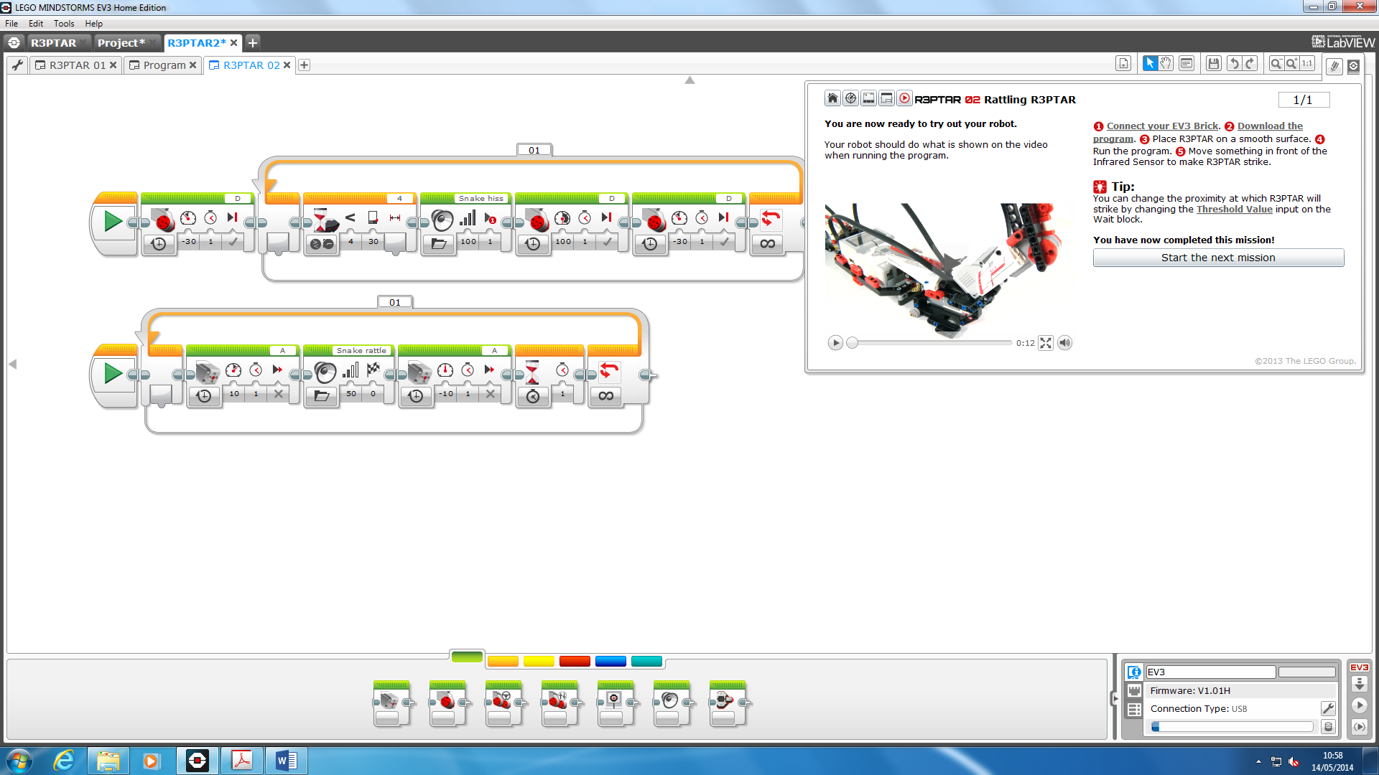

This screenshot shows the how we programmed the robot to do what we wanted it to do. As you can see the structure of it, this is the part where the robot uses the infrared sensor and waits for something to be in front so it can attack. The blue highlighted circle is the infrared sensor and as it goes into the loop, it waits attacks. It all goes in order of the instructions. The second one attacks without anyone putting his or her hand in front of the sensor

At the bottom-right, you can see a box. This is the part where we can download the program to put it onto our program. We can ‘download and run’ to see if it works.

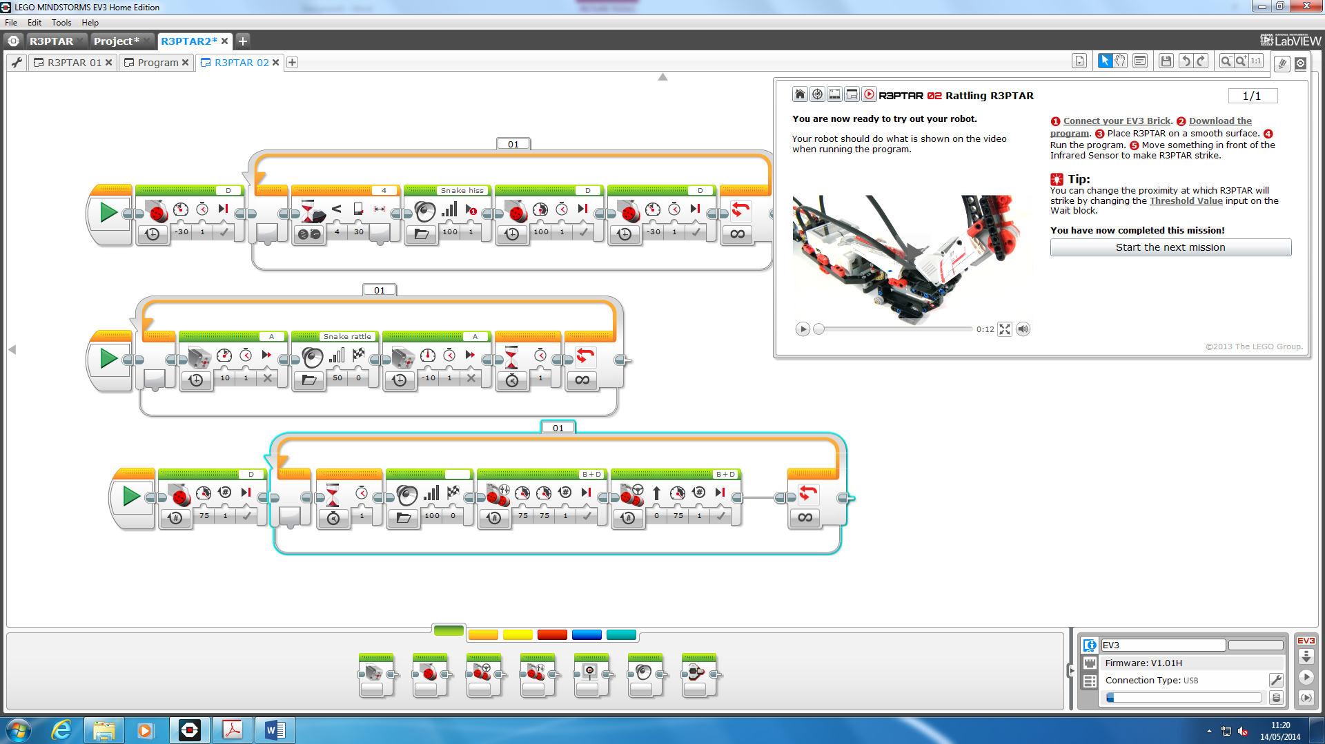

This is the extension of the first photo. The one added is the bottom one and we were testing the program to see if it works with the one we tried.

**TOUCH SENSOR**

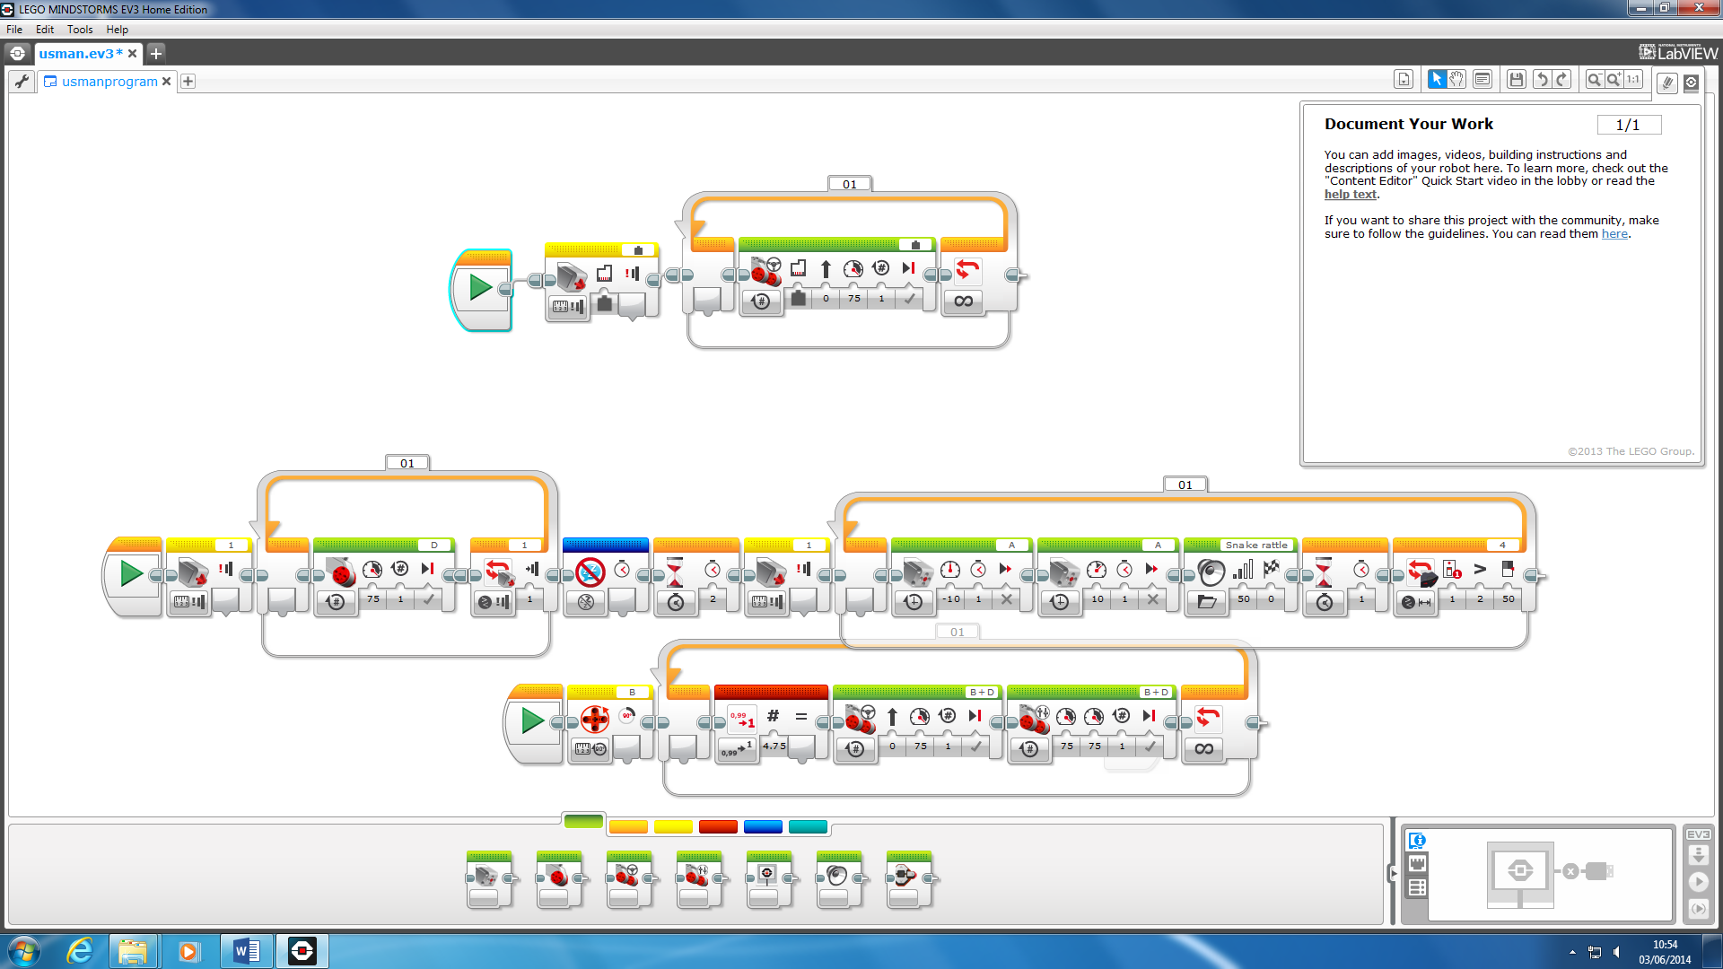

This is the touch sensor where we added the additional sensor onto our robot. We had to program it ourselves to make it work. As you see, we have the ‘yellow one’, which is the first one, and we have it to move and attack. However, the dark highlighted area it the part where it is programmed to wait once the touch sensor has been pressed. Once it has been pressed, it only attacks the opponent and does not do anything else. We ran it and it worked.

**Test plan**

|  |  |  |  |  |
| --- | --- | --- | --- | --- |
| **Test number** | **Description** | **Input data/values** | **Expected outcome** | **Actual outcome** |
| 1 - Motors | 3 Motors  Ports – A, B and C  Direction – Forward  Power – 100  Duration – Until the program is stopped | We’ve connected Ethernet cables from the motors to the brick so the data can be transmitted. | Motors respond to the program and robot is moving forward. | Motors responded, and they work appropriately as expected. |
| 2 – Ultrasonic Sensor | Ultrasonic Sensor  Control – Sensor  Sensor – Ultrasonic  Port – 1  Duration – until in range more than 100cm. | When we move the hand towards ultrasonic sensor, it should start moving the head as it says in the program | Robot will attack when it will recognise that something is in front of it. | The robot is attacking three times as we set it, and it works as we expected |
| 3 - Sound | Sound  Control – Speaker  Port – Controller  Duration – Gives a sound while attacking | We’ve inputted the sound into a program so it would give a sound of a snake, as it’s attacking its victim. | The sound is expected to be played after moving the hand to an ultrasonic sensor, so it would attack and play the sound at the same time. | The sound worked when we moved our hand towards ultrasonic sensor. This was proved when we tested a robot |
| 4 – Touch Sensor | Touch Sensor  Control – Sensor  Sensor – Touch  Port – 1  Duration – Until triggered | We’ve connected the touch sensor to the brick with internet cable. The software should stop the movement of the robot | When the sensor has been trigged, the robot should stop every movement and then after pressing it again, it should start again | The sensor has worked as we expected, however, we had to make sure that we set up the program right, as we had some problems with that, but we’ve solved it. |